

GENERAL EDİP BAYOĞLU PRIMARY SCHOOL



Civilization means forgiveness and tolerance. They are the primitive socities which have blood feud. The civilization which is not based on forgiveness and tolerance will collapse… It is not a civilization.
Mustafa Kemal Atatürk

Be so tolerant that you will be treated in that manner.
Hz. Muhammed

Those who pursue the goodness find goodness, but the badness find badness.
Hz. Mevlana

Act like the sun in love and compassion.
Act like a river in friendship and fraternity!
Act like the night in covering the faults of others!
Act like the soil in humility and selflessness
Act like dead one in anger and fury!
Either seem as you are or be as you seem.
Hz. Mevlana
TOLERANCE
Tolerance means disregarding, endurance, sufferance, liberating others in their actions, enduring patiently and fairly the opinions which are contrary to our views and and the view of the majority. It also means granting permission, ignorance and reception.
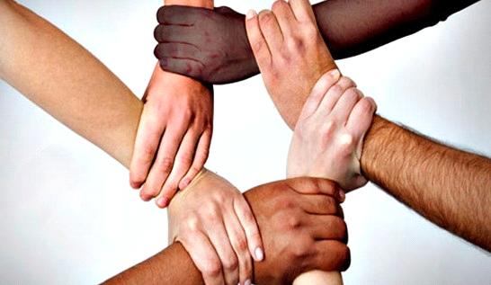

PITY
Protection, affection, help. Sense of pity which leads people to do others a kindness and help them. It is the main reason of good characters and behaviours such as approaching all created ones with affection, protecting and saving them from the badness, helping them in trouble situations, donating and forgiving. Its source is God. It is the manifestation and reflection of the pity in the humans and the mercy and pity of God.

STORY
There was a young boy of bad character. One day, his father gave him a bag full of nails. He said “Drive one nail in this wood every time when you discuss and fight with your friends.” The young boy drove 37 nails in the wood on the first day. In next weeks, he tried to control himself and he drove less nails every passing day.
At last, he didn’t drive any nail one day. He went and told his father. His father took him again in front of the wood. He said the young boy “From now on, take one nail out from the wood for every day when you don’t discuss and fight.”
Days passed. One day, every nail was taken out. His father said him “Well done! You behaved well but look at this wood carefully. There are a lot of nails. It will not be good anymore as in the past. “
He said “When discussed and fought with friends, bad words are said. Every bad word leaves a tear (hole). You can say your friend thousand times that you forgave him, but this hole will remain the same and won’t close. One friend is like a precious jewellery. He makes you laugh, encourages you, helps when you need, listens to you and opens his heart to you.”

EXAMPLE PERSONALITIES
Mustafa Kemal ATATÜRK
Hz. Muhammed(S.a.v)
Hz. Mevlana
Yunus EMRE
Hacı Bektaşi Veli

