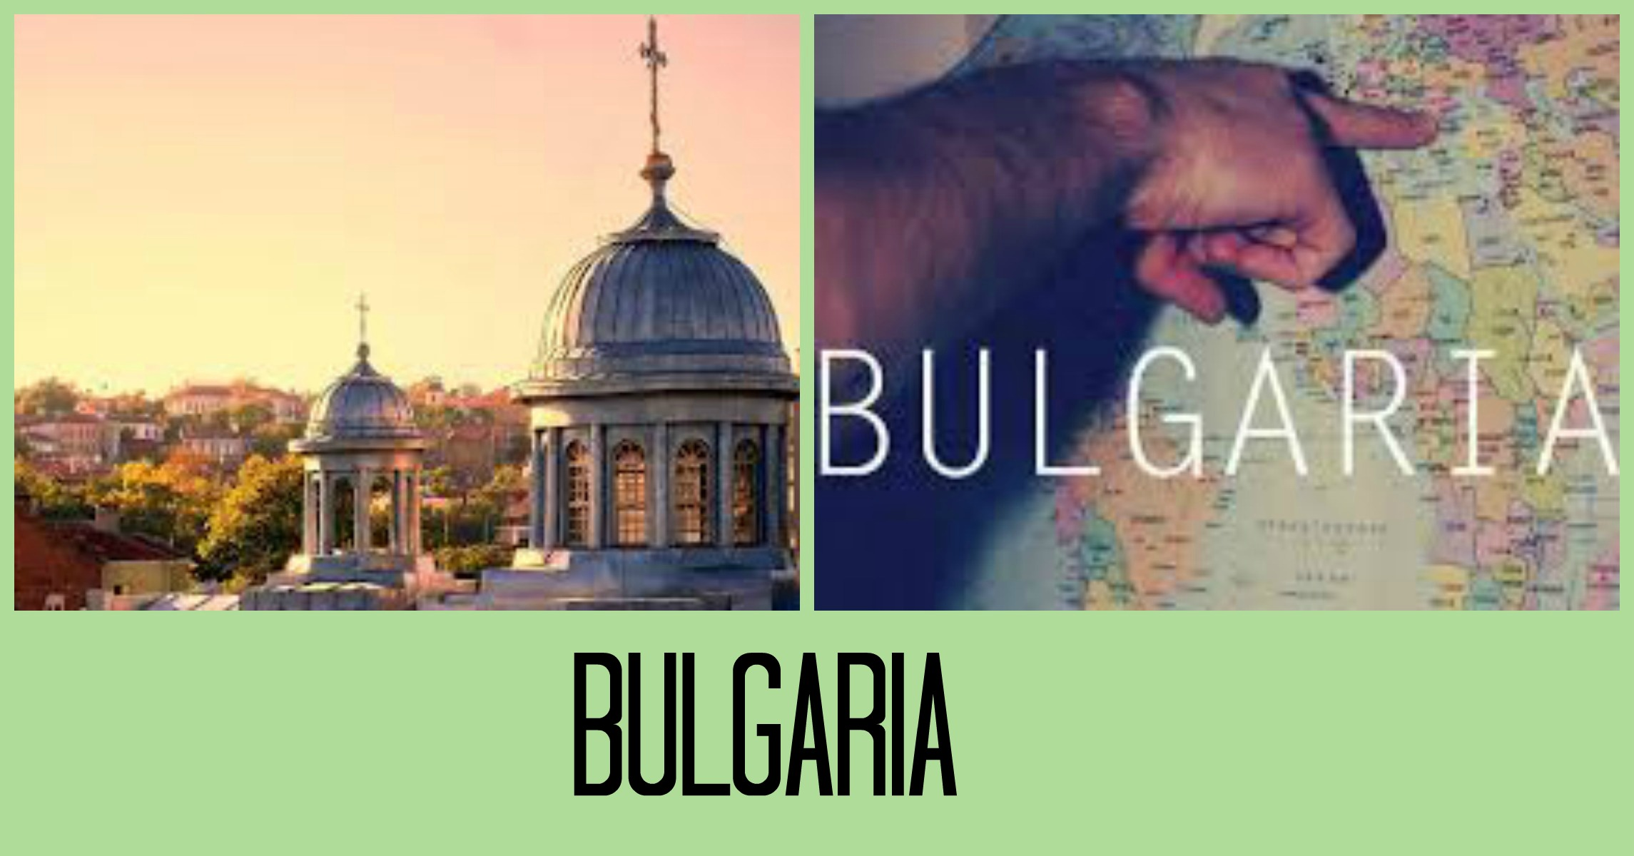

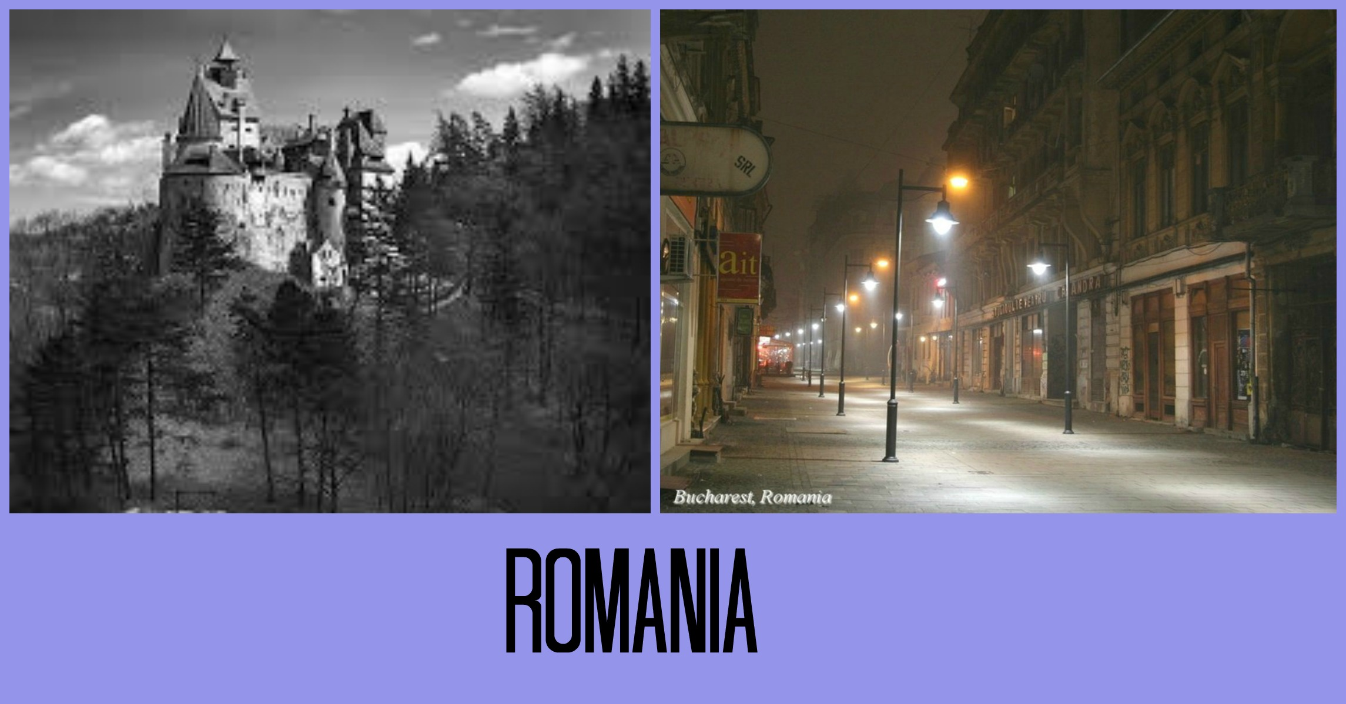

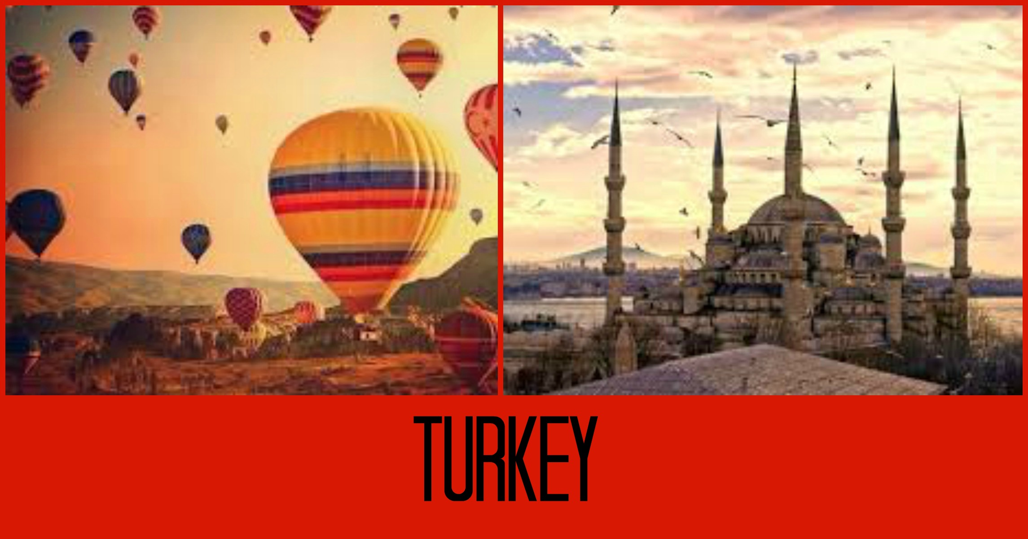

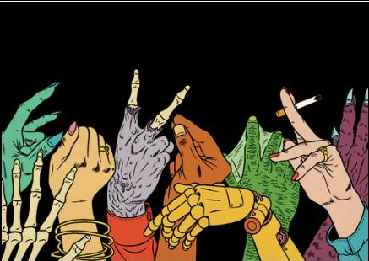
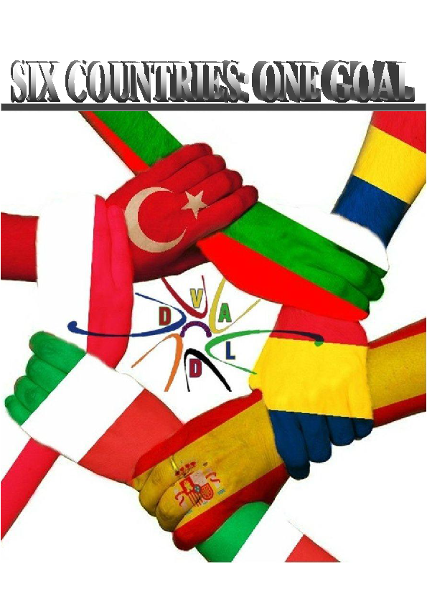
- We should treat us as equals

For Social Equality.

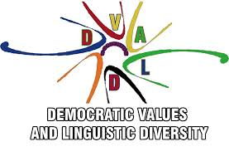

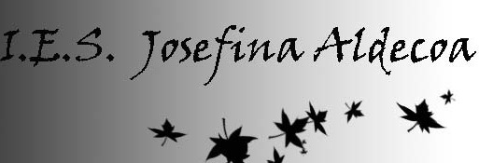

seeking to empower them to participate in the construction and defence of a universal culture of human rights in society , in order to promote and protect human rights and fundamental freedoms.
Education for democratic citizenship and human rights education are closely linked and mutually reinforcing. They differ more on the subject and scope than on the objectives and practices.
Education for democratic citizenship emphasizes democratic rights and responsibilities and active participation in relation to civic issues.

What are democratic values and value diversity?

Democratic values ​​are the characteristics, qualities, ideas and beliefs accepted in a society to strengthen the democratic process and to live in a peaceful and harmonious society.

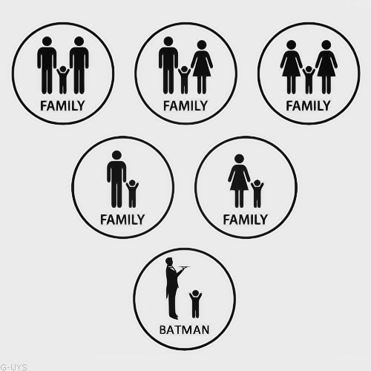
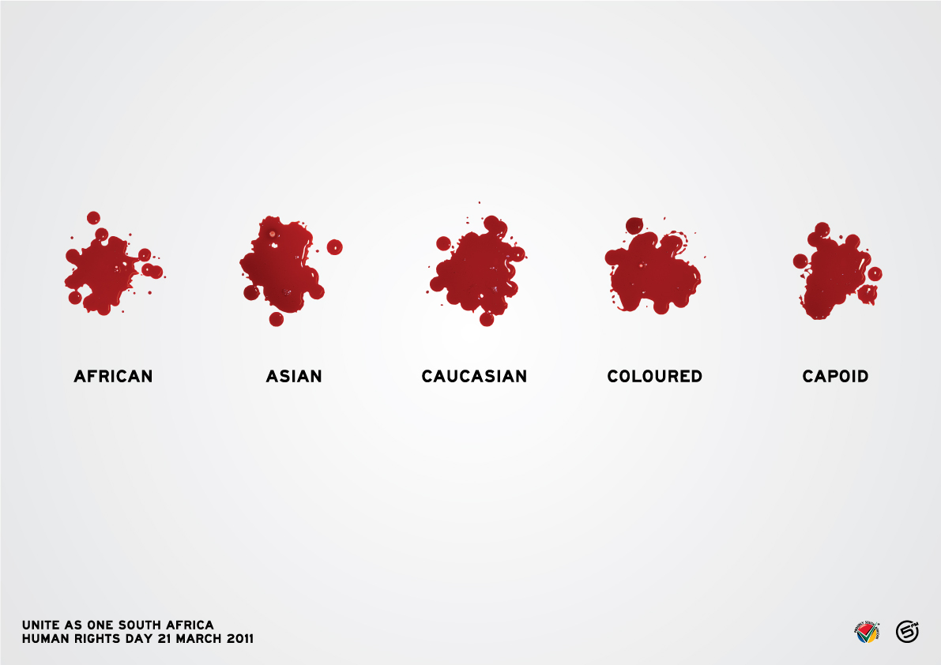
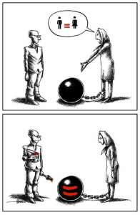
The values which that society ​​has to achieve are: freedom of action and assumption of obligations which are accepted by the majority of citizens; equality which ensures that all citizens have the same obligations; justice, which guarantees equality and freedom, security and peace; Tolerance to appreciate and value all the people...

❷ ❼
What are human rights?

What can we do to promote overall level citizenship and human rights education?
Education plays an essential role in promoting the fundamental values ​​of democracy, human rights and the rule of law and the prevention of human rights violations.

They are the rights which all the people have since they are born; the main intention of these rights is to promote respect for the rights of the human being: personal, political, economic, social and cultural.

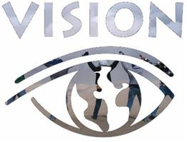

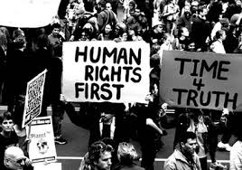

Education for democratic citizenship means, training, advocacy sensitization, information, practices and activities, it also provides students with knowledge, skills and understanding and develops their attitudes and behaviour, all these things are meant to empower them to exercise and defend their democratic rights and responsibilities in society.

The common characteristics of these rights are:
- Inborn humans: Humans have them all since they are born.
-Universal rights: they are for ALL humans.
-inalienable: nobody can remove them from any human being.
-Inviolable: you can not break or shatter them; if this is done it will be punished by law
-Imprescriptible: they will never expire or be lost by anyone.
“Human rights education " refers to education , training , advocacy , information , practices and activities , in addition to this, it contributes to students with knowledge, skills and understanding and developing their attitudes and behaviour,
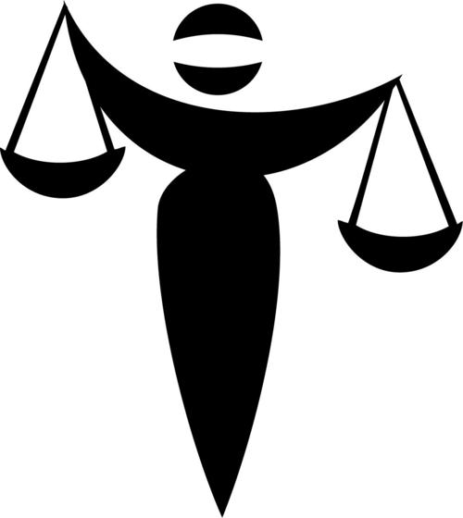

❻ ❸
What is human rights education?
Do we respect human rights and democracy in our school? Yes or not? Why and how?

It is a type of education that attempts to transmit the values ​​of peace, tolerance, and respect, so that citizens grow up free and aware of their rights and respectful with the others' rights.
Yes, democracy and all human rights are respected; in our school all the students are allowed to express themselves in a free way, without being judged. All the students and teachers respect all cultures, religions and the way of life of each person in the school, we freely choose our representatives democratically.

We are free in thought and belief, freedom of expression and opinion. No one is discriminated by any aspect. All of us are treated equally. Our school carries out a series of task to develop these values and pass them to all the students at the school so that we can reclaim and protect them.

These rights are imposed since citizens are young, because this way it is easier to learn, defend and respect the humans rights, and education on this area tries to stop or prevent abuse, in the long term, for a just and better society



Don’t like gay marriages? Don’t get one. Don’t like abortions? Don’t have one. Don’t like cigarettes? Don’t smoke one. Don’t like sex? Don’t do it. Don’t like porn? Don’t watch it. Don’t like alcohol? Don’t drink it. Don’t like your rights taken away? Don’t take away someone else’s.

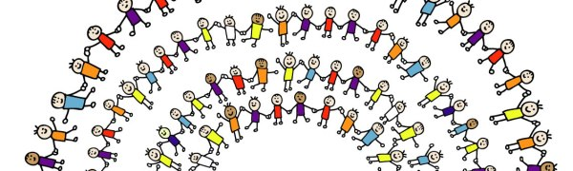

❹ ❺
What is democratic citizenship?

Democracy is a form of organizing groups of people; the most important characteristic is that the power lies in the decision of the biggest number of members.
There are two types of democracy, direct and indirect:

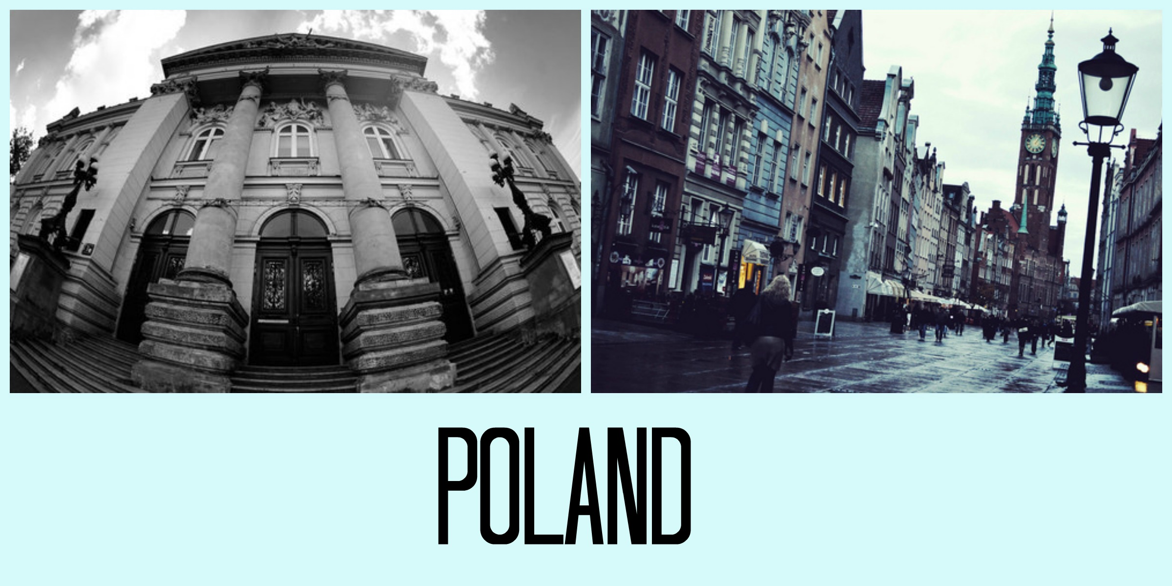
-Direct: when decisions are taken directly by the people
-Indirect: when the opinion of the majority of the people is represented by a representative.

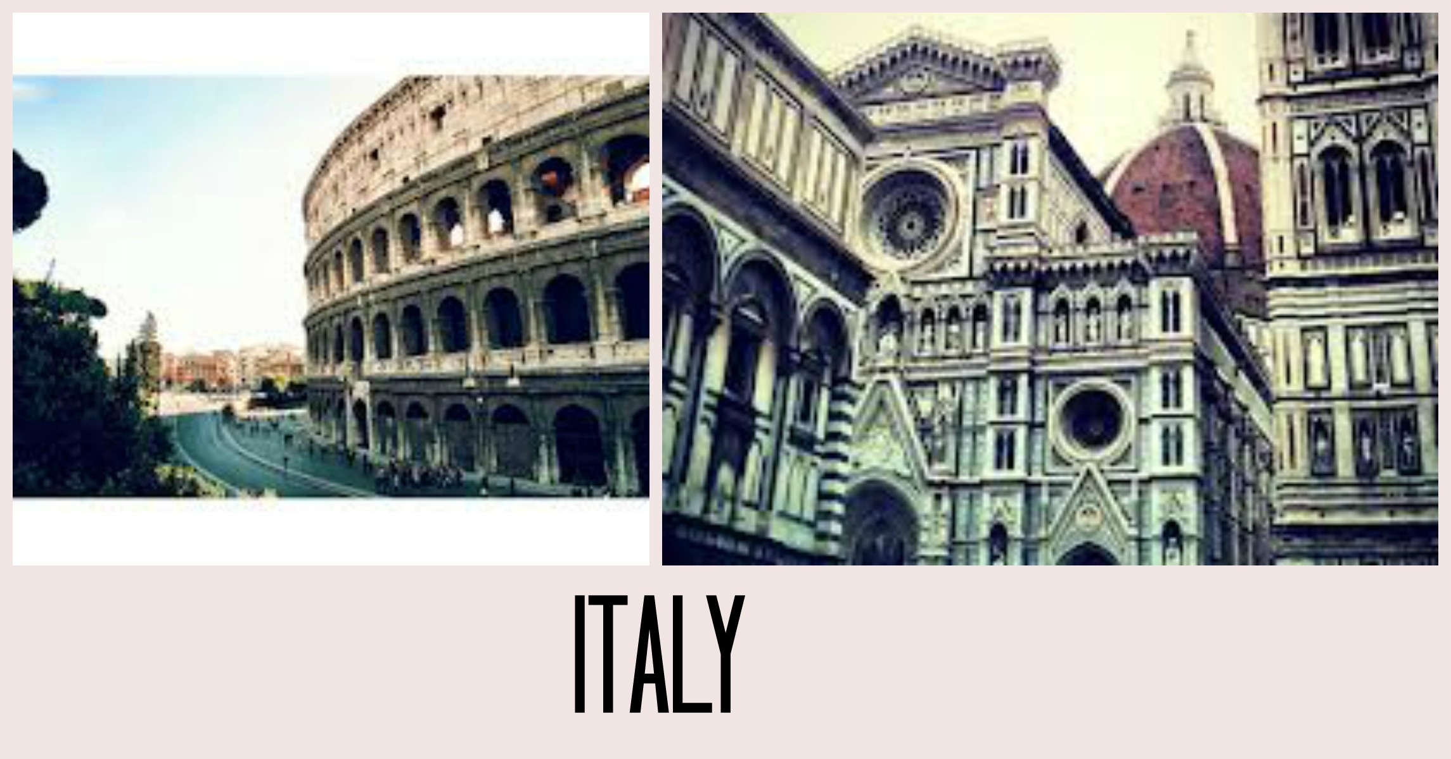

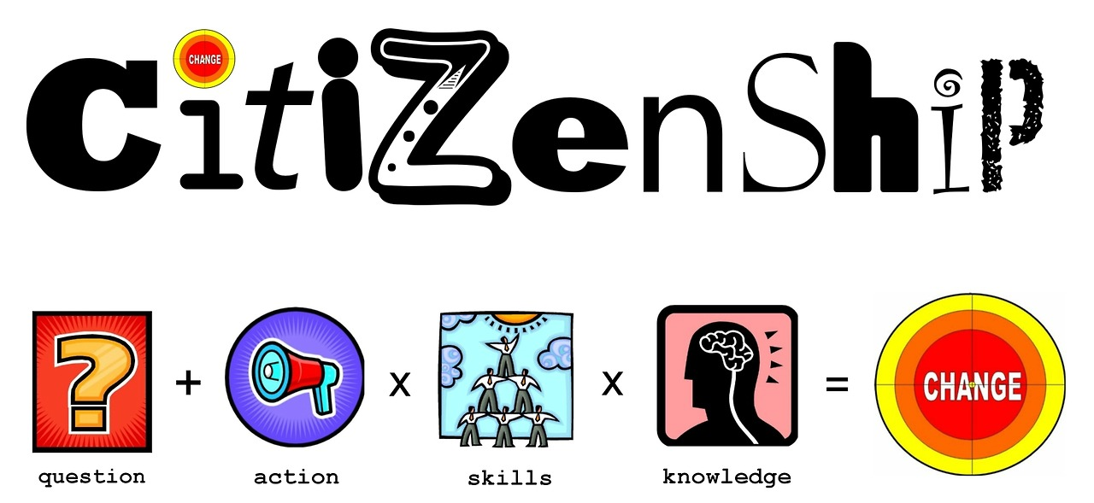

But there is also a participatory democracy, in which those two first types are combined. These types of democracy must fulfil the developments of human beings, which are: to promote human participation, to live, to appreciate and express civic and democratic values. Because to develop our capacities as human we need to belong to social groups, this belonging strengthens our ties and makes our society progress, whose values are freedom, equality, solidarity, criticism and civic values.

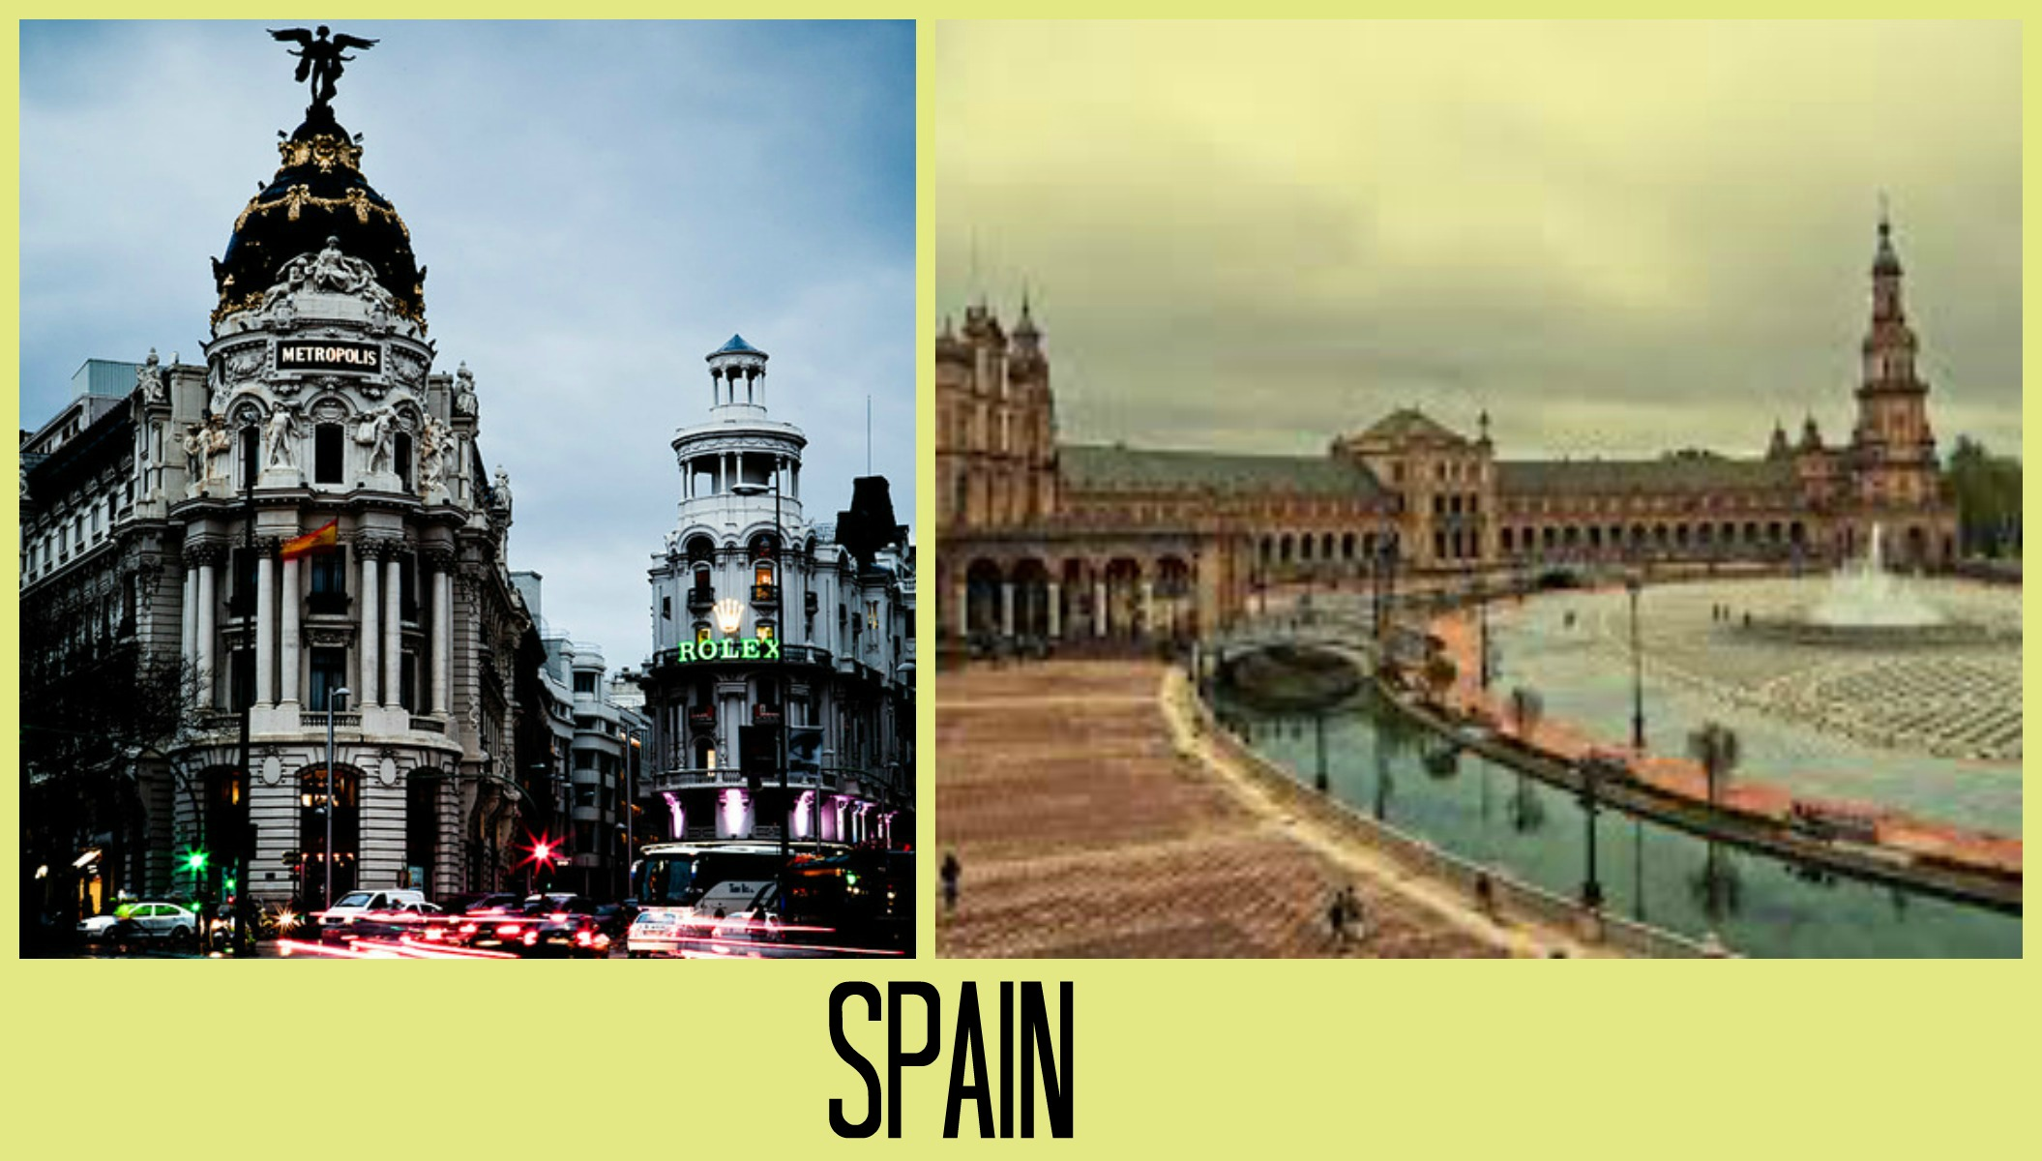

❽ ❶

