INTRODUCTION

Our duty as citizens and participants in the Comenius Project is to respect Democratic Values.
Our purpose is to explain how they are practiced through our Food and Nutrition book. After revising the different Democratic Values, we have come to the conclusion that both Food and Nutrition help us to fulfill these values in everyday life.
How do we do that? By sharing culinary, religious and cultural traditions; by gestures such as choosing products whose treatment has respected essential human rights such as child exploitation injustice.
Furtheremore, sitting down at a table with other family members or with our friends makes us talk to each other, share opinions and respect everyone, in short, enrich one another.
Secondly, food encourages us to respect psychological features from other people. For example, helping, by working out specific menus or sharing them with people who suffer from food disorders such as anorexia or bulimia, or allergies to specific foods.
In conclusion, food and nutrition make us both healthier and more democratic.

WHAT DO WE NEED TO KNOW ABOUT HOW TO FEED OURSELVES CORRECTLY?
We know that food give us the necessary nutrients to have a healthy body. But...
What are nutrients?
Nutrients are the carbohydrates, proteins, fats, vitamins, mineral salts and water which are indispensable for life. Our body gets this nutrients from food.Nutrients give us energy and all what we need in order to create and renew our body structure andregulate our metabolism.
How many types or nutrients are there?
Body-building nutrients
Body-building nutrients are in charge of our body structure: muscles, guts...
The main body-building nutrients are proteins. Which food are rich in proteins?

Some of them come from meat, fish, seafood, eggs, milk... They also come from derivates such as cheese, stuffed meat, paté, yogurts, etc. These proteins are the best for our diet.

Some others come from vegetables such as legumes and nuts. These proteins are less rich for us than the other group, but when combined with cereals proteins can be obtained in a similar way to those of the animals.

Energy nutrients
Energy nutrients are in charge of giving us the necessary energy to do our daily activities such as working, studying, walking, protecting us from cold, etc.

The main energy nutrients are lipids and carbohydrates. Which food is rich in carbohydrates? Pasta, biscuits, bread, cereals, rice, potatoes, honey and suits.

Within carbohydrates, fibre is very important because it allows a better bowel transit.

Within lipids, triglycerides are the main components of fat contained in food. There are three kinds of fat:
- Saturated fat: It can be found in animals such as pork, veal and lamb. It can also be found in all their derivative products like butter, cream, cheese, cold meat, and mostly in pastries and processed-baked goods. However, there is also some food of vegetable origin that contains this kind of fat, and they are the coconut oil and the palm oil used in the production of bakery food.
- Monounsaturated fat: It is found in olive oil, olives, dried fruit and nuts and avocados.
- Polyunsaturated fat: It is located in food which is full of omega 6 fatty acid, for example, sunflower, soy, and corn oil. There is also food that contains omega 3fatty acid, and they are fish and walnuts.

Regulating nutrients
These nutrients have not an energetic value but they are essential for the good functioning of our body. These are water, vitamins and mineral salts.What kind of food contains these nutrients? With a daily balanced diet and rich of fresh and whole-wheat products, you will meet the need of them.
Let’s speak about vitamins. In relation to vitamins, there are two kinds: Fat-soluble vitamins (A, E,D, K), which are dissolved in fat, and water-soluble vitamins (C and complex B), which are dissolved in water. Fat- soluble vitamins are accumulated in the liver and fatty tissue, but if they are consumed in excess, they may become toxic. Nevertheless, water-soluble vitamins are not accumulated, so there must be consumed regularly. If they are consumed in excess, they are eliminated by urine, so there is not a toxic effect. Each kind of food has its own vitamins, and fat-soluble ones are found especially in liver, fatty fishes, butter, milk, eggs, dried fruit and nuts, etcetera. In general, fresh food such as vegetables and fruits are rich of water-soluble vitamins.
What do we have to do to get these nutrients?
Not every food contains all the nutrients, some foods are richer in nutrients than others.For this reason we must feed ourselves by consuming a large variety of foods to ensure this way that we get all necessary nutrients.
An easy way of knowing whether all nutrients are included in our diet is by checking the food pyramid.
The food pyramid is a graphic that indicates us which type of food must be included in our diet and which is the recommended dose to have a balanced diet.
Before talking about the food pyramid, we have to make this clear:
What is a balanced diet?
The diet that contains all the necessary foods to be correctly nourished, that is to say, the one which provide us with the right quantities of regulating, plastic and energetic foods. According to the experts, these daily quantities are as follows:
- 60% of carbohydrates
- 15% of fruit and vegetables, either fresh or cooked.
- 15 % of meat and fish,....that means proteins.
- 10% of food rich in fat..

These quantities have to be adapted to:
- The personal conditions of each individual such as age, sex, height, physical activity, etc.
- The environmental conditions such as temperature.

Now that we know what a balanced diet is, let’s go back to

Food Pyramid
In the food pyramid of next page, there are a series of steps.
- The food which is located at the basis of the pyramid, which is the widest, are the ones which should be eaten daily and in big quantities. This food provides us energy because they are full of carbohydrate: bread, cereals, rice, pasta, potatoes, and flour.
- In the next step we can find the regulator food: fruits and vegetables.We can add olive oil to cook or dress them.
- The third step is characterised by milk and its derivatives. They are a source rich in calcium, and proteins.
- The food with less necessity toeat is placed in the fourth step, and they correspond to the food with protein content: lean meat, fish, eggs, legumes and dried fruit and nuts.
- At the top of the pyramid we have that food that must not be eaten frequently because they are rich in fat: cold meat, butter, margarine, sweets, and processed baked goods.

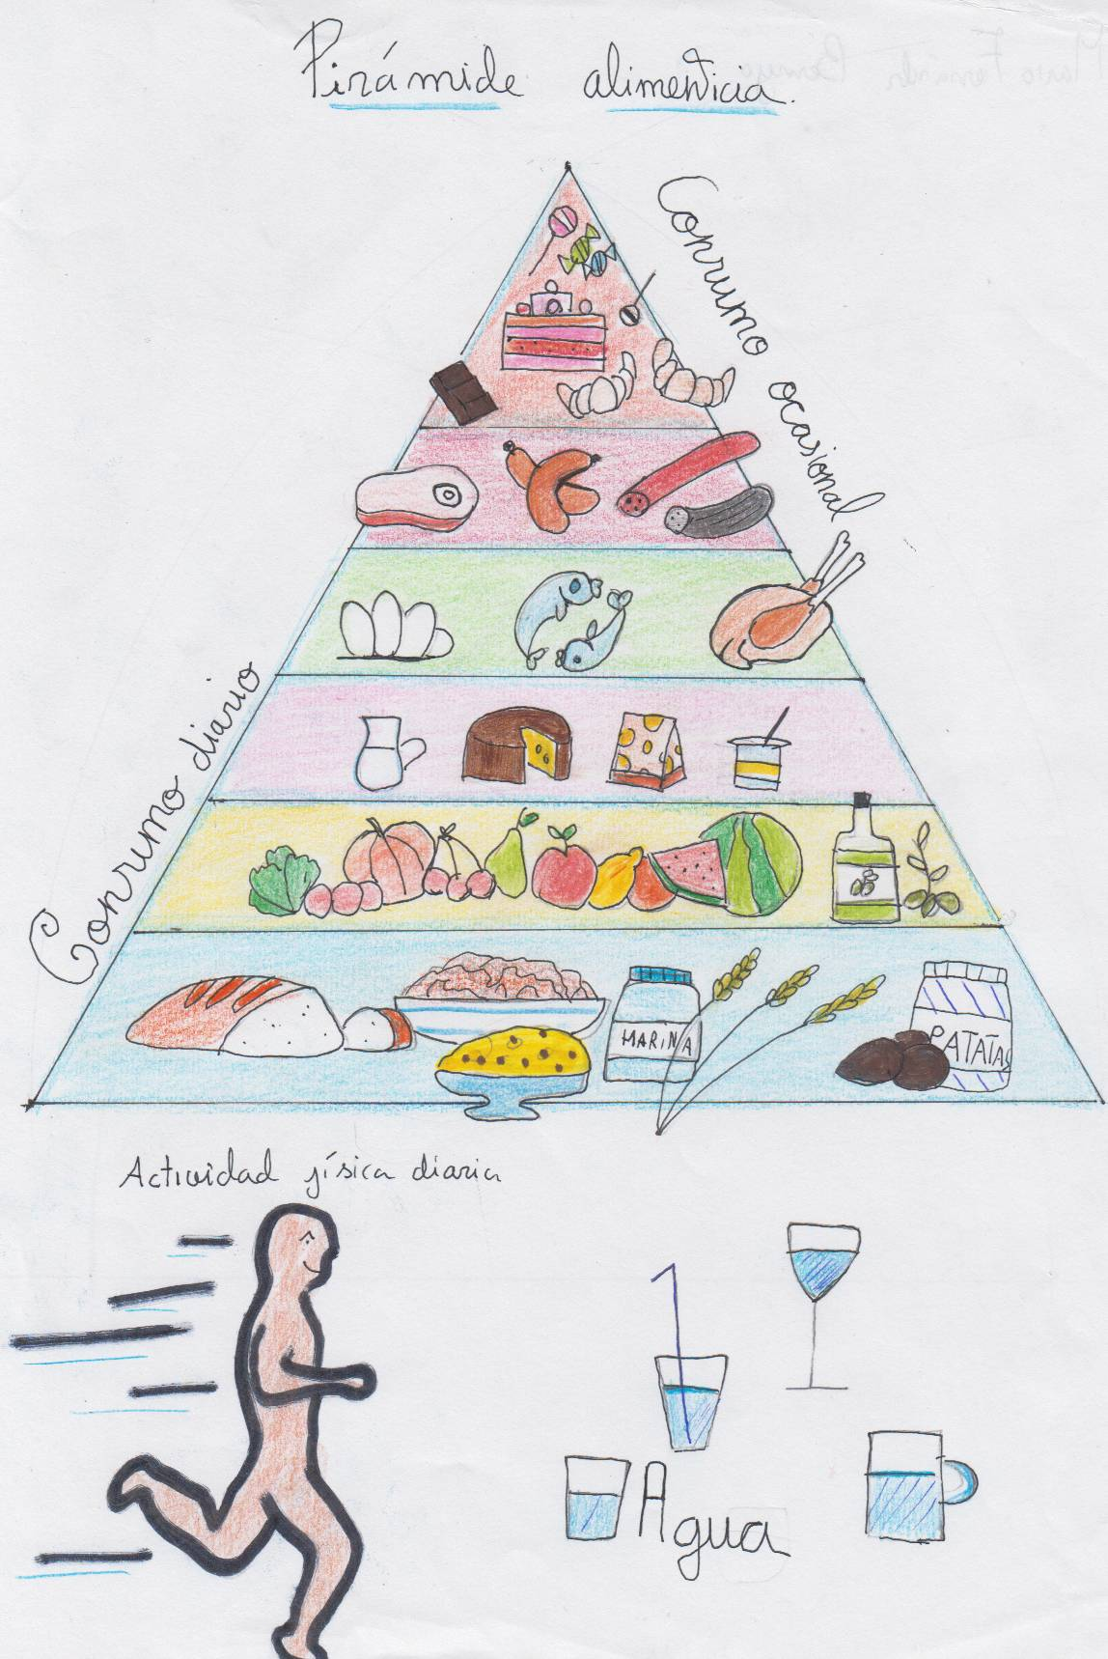

Mario Fernández Bermejo E3A

OUR BALANCED DIETS
1- The Mediterranean diet.
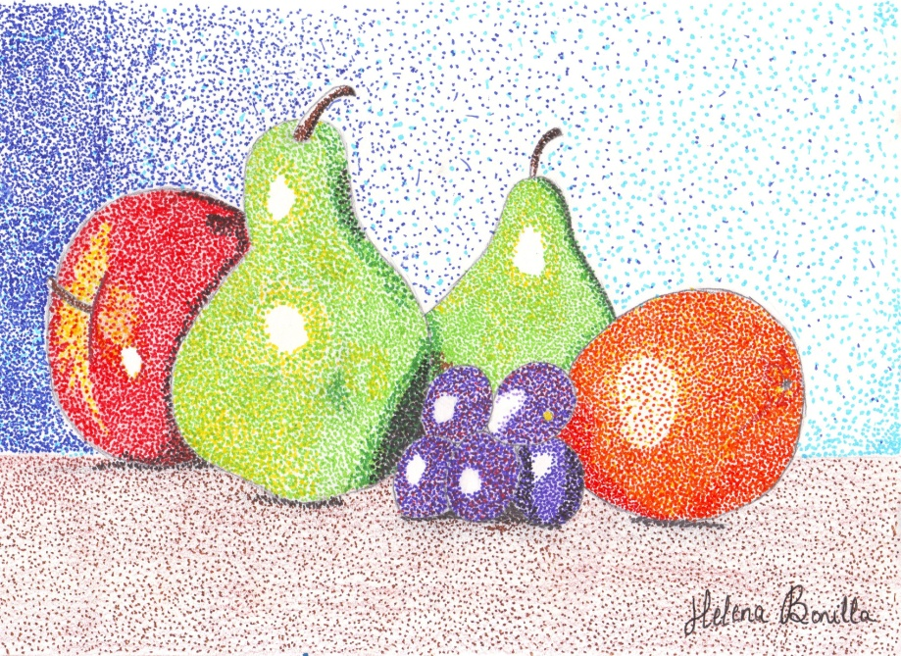
It is typical of countries which are located in the Mediterranean Basiun such as Spain, Italy, France, Greece, Cyprus, Tunisia, Albania, Malta, and so on. Although this diet has got common featureswhich define it, every country contributes with its own peculiarities.

Which foods arepart of it?
- Olive oil, not only to fry but to season as well.
- Plenty of foods which are of vegetable origin, rich in fibre like vegetables, fruit, pulses. Preferablyif they are seasonal. Salads are a part of almost every meal, which usually finishes with a piece of fruit as dessert.
- Nuts, honey and olives, but with moderation.
- Daily consumption of a moderate amount of cheese and yoghurt.
- Proteins, rather than in red meat, can be easily found in fish, eggs and poultry.
-Carbohydrates are provided by fresh bread, pasta, potatoes and rice.

- Use of products like garlic or onion, and some spices and aromatic herbs.
- Drinking water is very important in the Mediterranean diet although, just in the case of adults, some wine could be included in the main meals with moderation, especially red wine.
- To all these things, we may add healthy, cultural habits like:
*Careful and simple preparation of the dishes, making them tasty and visually
attractive too.
* Meals shared with family and friends.
* Eating in a relaxing way, enjoying the meal.
* Doing some physical activity regularly.

What advantages does this have?
Basically, it protects us from cardiovascular diseases and some types of cancer.

On this webpage, you have menus, games, recipes and some other curiosities about the Mediterranean diet.
http://dietamediterranea.com/en/

